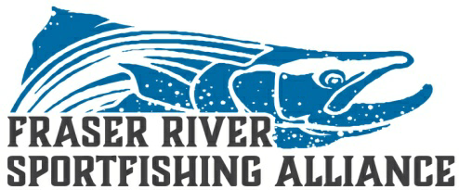

Urgent Notice:

Over the past several years the FRSA and member organizations individually and through the Sport Fish Advisory Board have tried to secure a selective bar fishery on the Fraser River. Despite our attempts to work with DFO staff this request continues to be denied. This method of angling has proven to be truly selective and is an important part of our fishing heritage. A recent request to access healthy runs of late chinook in river was again denied despite openings at the mouth & on-going net fisheries. To further demonstrate our ability to fish selectively the FRSA and member organizations have arranged a Demonstration fishery to be held Sept 9th to further document our valid requests for equitable opportunity.

If you are concerned about the angling opportunities for your future generations please attend this event to be launched from Island 22 boat launch Wed Sept 9th. Boat transportation will be provided to designated fishing areas where possible. Please ensure you have a valid fresh water license and be at the launch at 7:30 AM for further details.

All participants will be expected to act respectfully toward any DFO staff and other sectors on the river. This is not a protest!! Lets demonstrate we can be respectful while demanding equitable opportunities going forward. Please follow Covid 19 guidelines and socially distance.

